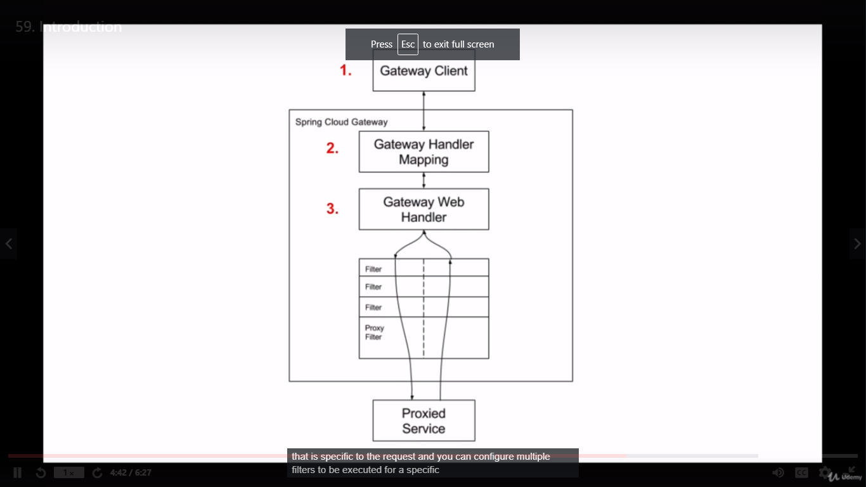

<https://www.javainuse.com/spring/cloud-gateway#:~:text=Spring%20Cloud%20Gateway%20is%20a,completed%20the%20response%20is%20returned>.

https://www.baeldung.com/spring-cloud-gateway